# I.P. COLLEGE, CAMPUS-II, BULANDSHAHR



**A**

**Project Report Entitled**

***“College Management System”***

**As Minor Project**

## Based on summer training held after fourth semester

**Batch (2020 – 2023)**

## CH. CHARAN SINGH UNIVERSITY, MEERUT

|  |  |  |
| --- | --- | --- |
| **Under The Distinguish Guidance of: -** | **Submitted By: -** |  |
| Mrs. Ginni Dua (Asst. prof.) | **Group No: -** 21 |
| Dept. of Computer Science | **Name** | **Roll-No.** |
| I.P. College Campus-II, Bulandshahr | Yash Gupta | 200955106196 |
|  | Yash Gupta | 200955106195 |
|  | Sahil Gupta | 200955106141 |
|  | Navya | 200955106101 |
|  | Sakshi Kumari | 200955106142 |

**Class: -** BCA IIIrd Year

**CATEGORY**

Hybrid

Application

### ACKNOWLEDGEMENT

We take this opportunity to express our sincere thanks and deep gratitude to all those people who extended their whole hearted

Co-operation and have helped us in completing this project successfully.

We acknowledge the effort of those who have contributed significantly to our project. We express our sincere altitude and thank-fullness towards **Dr. T.N. MISHRA** (Principal of I.P. (P.G.) College Capmus-2 NH-91, Delhi Road, Bulandshahr) has provided such a talented faculty to us then We would like to thank **Mr**. **SANJAY KUMAR** (Head of Department) for their guidance throughout BCA.

We sincerely thank to our guide **“Guide Name Mrs. Ginni Dua”** for his inspiring guidance and constant motivation. Every time we were lurking in the dark. She shows us the way out.

We should like to express our gratitude to other faculty members of our college for their reviews and many helpful comments.

Finally, the project would not have been possible without confidence, endurance and support of our group members.

###### Name of Group Member

Yash Gupta [200955106196]

Yash Gupta [200955106195]

Sahil Gupta [200955106141]

Navya [200955106101]

Sakshi Kumari [200955106142]

### STUDENT DECLARATION

We, solemnly affirm and declare that the project **“College Management System”** under the guidance of “**Mrs. Ginni Dua”** our original work. No part of this work whether documentation and coding has not been copied or taken in any form and by any means.

We certify that our project is original and it has been made as minor project based on summer training held after BCA IVth semester.

###### Group members name with roll no. Signature

Yash Gupta [200955106196]

Yash Gupta [200955106195]

Sahil Gupta [200955106141]

Navya [200955106101]

Sakshi Kumari [200955106142]

### CERTIFICATE

This is to certify that the project report entitled, **“College Management System”** is a beneficed work done by:

1. Yash Gupta [200955106196]

2. Yash Gupta [200955106195]

3. Sahil Gupta [200955106141]

4. Navya [200955106101]

5. Sakshi Kumari [200955106142]

Student of BCA IIIrd Year Batch (2020-2023) as minor project report carried out under my supervision and guidance.

To the best of my knowledge this project work is genuine.

……………………………… Signature of Guide

Mrs. Ginni Dua Asst. prof.

Dept. of Computer Science

I.P. College, Campus-II, Bulandshahr

Date: …………….

### TABLE OF CONTENT

#### ABOUT THE PROJECT

* 1. INTRODUCTION
  2. OBJECTIVE

#### PRELIMINARY INVESTIGATION

* 1. TOOLS PLATFORM USED
  2. HARDWARE/SOFTWARE USED

#### FEASIBILITY STUDY

* 1. OPERATION FEASIBILITY
  2. TECHNICAL FEASIBILITY
  3. ECONOMICAL FEASIBILITY

#### INFORMATION GATHERING

* 1. ON-SITE OBSERVATION
  2. QUESTIONAIRE
  3. INTERVIEWING

#### REQUIREMENT ANALYSIS

* 1. DATA FLOW DIAGRAM(DFD)

#### LOGICAL DESIGN

1. DATABASE DESIGN

#### PHYSICAL DESIGN

* 1. OUTPUT REQUIREMENT
     + USER INTERFACE DESIGN
     + OUTPUT REPORT DESIGN
  2. INPUT REQUIREMENT

#### TESTING

1. **MAINTENANCE**

#### SCREENSHOTS

#### LIMITATIONS / FUTURE SCOPE

1. **REFRENCES/BIBLIOGRAPHY**
   1. WEB SITE
   2. YOUTUBE

# ABOUT THE PROJECT

## INTRODUCTION

**OBJECTIVE**

### INTRODUCTION

Management system is a very important and essential part of any educational institute. The project defines the all arrangement of college system. College management system means it controls all the management tasks and functions. It performs all function which requires to any educational institute. Admin can vie and change all record of the college. Techer can also view their information and they can change personal information. Student can search their result. They can see more information about the college on the college management system software. They can see their time table of the lectures in the college. They can see also their exam date fee data and personal information. Student can print out their roll no. slip with just one click. Student can view rules and regulation for college in detail.

Student can view their fee detail for previous semester student can view there all fee package admission details the detail of courses completed and pending courses and repeating courses. Students can view academic calendar. Students can view their course evaluation forms at the end of each semester and ca give suggestions to make the program and educational environment better.

Teacher have been authorized this site to update results, attendance on daily bases. Teacher can view all details of each student of any semester.

Management system is a very important part of any educational institute. The project defines the all management of college system. College management system means it controls all the management tasks and functions. It performs all the function which require to any educational institute. Admin can view and change all records of the college. Teacher can also view their information and they can personal information. Students can search their result. They can see more information about the college on the college management system software.

### OBJECTIVES

* We can add, modify, search and delete data about teachers, students and others staff of the college.
* It contains teacher and other staff ‘s personal information.
* It contains the teacher and other staff ‘s attendance.
* It saves the data of teachers and other staff’s salary.
* It contains the personal information.
* It contains the personal information of the students.
* It manages the fee of students.
* It manages the exam management system.
* It contains more information about the college.
* It contains also the time table of the lectures.
* Students can view rules and regulations for college in details.
* Students can view their fee details of previous semester and current semester. Students can view there all fee package admission details the details of courses completed and pending courses are repeating courses. Students can view academic calendar.
* Students can fill their course evaluation form at the end of each semester and can give suggestions to make the program and educational environment better.
* Teachers have been authorized at this site to update result, attendance on daily basses. Teacher can view the detail of ant student of any semester.
* The main purpose of this site is to save time and save paper working as students can see their personal and educational details online. This site will help the management to control the educational system online more effectively. As everything is online in this site as resultant the coordinate between the staff will be strong. This site will be help financially to the management as computer work save time and reduce staff. The work of days can be done in minutes.
* The students can view all details online so they will not rush at offices to take their fee voucher’s and can’t ask result from the examination office as it is already updated on this site.

# PRIMARILY INVESTIGATION

## TOOLS AND PLATFORM USED

1. **HARDWARE/SOFTWARE USED**

### TOOLS AND PLATFORM USED

#### VS CODE

* **ANDROID STUDIO**

#### FIREBASE CONSOLE

**VS CODE**

##### HISTORY

Visual Studio Code was first announced on April 29, 2015, by Microsoft at the 2015 Build conference. A preview build was released shortly thereafter.

On November 18, 2015, the source of Visual Studio Code was released under the MIT License, and made available on GitHub. Extension support was also announced. On April 14, 2016, Visual Studio Code graduated from the public preview stage and was released to the Web. Microsoft has released most of Visual Studio Code's source code on GitHub under the permissive MIT License, while the releases by Microsoft are proprietary freeware.

##### FEATURES

Visual Studio Code is a source-code editor that can be used with a variety of programming languages, including Java, JavaScript, Go, Node.js, Python, C++, C, Rust and Fortran. It is based on the Electron framework, which is used to develop Node.js web applications that run on the Blink layout engine. Visual Studio Code employs the same editor component (codenamed "Monaco") used in Azure DevOps (formerly called Visual Studio Online and Visual Studio Team Services).

Out of the box, Visual Studio Code includes basic support for most common programming languages. This basic support includes syntax highlighting, bracket matching, code folding, and configurable snippets. Visual Studio Code also ships with IntelliSense for JavaScript, TypeScript, JSON, CSS, and HTML, as well as debugging support for Node.js. Support for additional languages can be provided by freely available extensions on the VS Code Marketplace.

Instead of a project system, it allows users to open one or more directories, which can then be saved in workspaces for future reuse. This allows it to operate as a language-agnostic code editor for any language. It supports many programming languages and a set of features that differs per language. Unwanted files and folders can be excluded from the project tree via the settings. Many Visual Studio Code features are not exposed through menus or the user interface but can be accessed via the command palette.

This includes additions to the editor and language support. A notable feature is the ability to create extensions that add support for new languages, themes, debuggers, time travel debuggers, perform static code analysis, and add code linters using the Language Server Protocol.

#### ANDROID STUDIO

Android Studio is the official integrated development environment (IDE) for Google's Android operating system, built on JetBrains' IntelliJ IDEA software and designed specifically for Android development. It is available for download on Windows, macOS and Linux based operating systems. It is a replacement for the Eclipse Android Development Tools (E-ADT) as the primary IDE for native Android application development.

Android Studio was announced on May 16, 2013, at the Google I/O conference. It was in early access preview stage starting from version 0.1 in May 2013, then entered beta stage starting from version 0.8 which was released in June 2014. The first stable build was released in December 2014, starting from version 1.0. At the end of 2015, Google dropped support for Eclipse ADT, making Android Studio the only officially supported IDE for Android development.

On May 7, 2019, Kotlin replaced Java as Google's preferred language for Android app development. Java is still supported, as is C++.

##### FEATURES

Android Studio supports all the same programming languages of IntelliJ and C Lion e.g., Java, C++, and more with extensions, such as Go. and Android Studio 3.0 or later supports Kotlin and "all Java 7 language features and a subset of Java 8 language features that vary by platform version." External projects backport some Java 9 features. While IntelliJ states that Android Studio supports all released Java versions, and Java 12, it's not clear to what level Android Studio supports Java versions up to Java 12 (the documentation mentions partial Java 8 support). At least some new language features up to Java 12 are usable in Android.

Android Virtual Device (Emulator) to run and debug apps in the Android studio.

Android Studio supports all the same programming languages of IntelliJ and C Lion e.g. Java, C++, and more with extensions, such as Go;[20] and Android Studio 3.0 or later supports Kotlin[21] and "all Java 7 language features and a subset of Java 8 language features that vary by platform version."[22] External projects backport some Java 9 features.[23] While IntelliJ states that Android Studio supports all released Java versions, and Java 12, it's not clear to what level Android Studio supports Java versions up to Java 12 (the documentation mentions partial Java 8 support). At least some new language features up to Java 12 are usable in Android.[24]

### FIREBASE CONSOLE

Firebase evolved from Envolve, a prior startup founded by James Tamplin and Andrew Lee in 2011. Envolve provided developers an API that enables the integration of online chat functionality into their websites. After releasing the chat service, Tamplin and Lee found that it was being used to pass application data that were not chat messages. Developers were using Envolve to sync application data such as game state in real time across their users. Tamplin and Lee decided to separate the chat system and the real-time architecture that powered it. They founded Firebase as a separate company in 2011 and it launched to the public in April 2012.

In May 2012, a month after the beta launch, Firebase raised $1.1 million in seed funding from venture capitalists Flybridge Capital Partners, Greylock Partners, Founder Collective, and New Enterprise Associates. In June 2013, the company further raised $5. Series A funding from Union Square Ventures and Flybridge Capital Partners.

In 2014, Firebase launched two products: Firebase Hosting and Firebase Authentication. This positioned the company as a mobile backend as a service [citation needed].

In October 2014, Firebase was acquired by Google. A year later, in October 2015, Google acquired Divshot, an HTML5 web-hosting platform, to merge it with the Firebase team.

In May 2016, at Google I/O, the company's annual developer conference, Firebase introduced Firebase Analytics and announced that it was expanding its services to become a unified backend-as- a-service (BaaS) platform for mobile developers. Firebase now integrates with various other Google services, including Google Cloud Platform, AdMob, and Google Ads to offer broader products and scale for developers. Google Cloud Messaging, the Google service to send push notifications to Android devices, was superseded by a Firebase product, Firebase Cloud Messaging, which added the functionality to deliver push notifications to both iOS and web devices.

In July 2016, Google announced that it was acquiring the mobile developer platform LaunchKit, which specialized in app developer marketing, and would be folding it into the Firebase Growth Tools team. In January 2017, Google acquired Fabric and Crashlytics from Twitter to add those services to Firebase.

In October 2017, Firebase launched Cloud Firestore, a real-time document database as the successor product to the original Firebase Realtime Database.

#### HARDWARE REQUIREMENT

* Processor: minimum 1 Ghz; recommended 2 Ghz or more
* Ethernet connection (LAN) OR a wireless adapter (Wi-Fi)
* Hard Drive: Minimum 32 GB; Recommended 64 GB or more
* Memory (RAM): Minimum 1GB; Recommended 4 GB or above

#### SOFTWARE REQUIREMENT

* Microsoft .Net framework 3.5
* Microsoft Visual Studio 2008
* Microsoft ASP .Net 3.5
* Microsoft SQL Server 2005
* DART language
* Android studio

# FEASIBILITY STUDY

## OPERATION FEASIBILITY

1. **TECHNICAL FEASIBILITY**

## ECONOMICAL FEASIBILITY

### OPERATION FEASIBILITY

In operational feasibility we will have to satisfy the requirements of customer who wanted to develop the software. In other words, the developer has to complete all the requirements which is given by the user to the developer and the developer have to give all the facility to the user which is given by the user to the developer.

In our program there are all facility are present which are have to present in a well college management software there are so many types of facilities are present in our software like -

1. Attendance of the teacher and student can do easily and without paper work by using our software under the program online attendance are available it is very beneficial for the any type of college because it can save the time in the lecture time.
2. The students and teacher can also take personal information in the college management system. If the students want to see the personal and the any type of information about himself so, the student can get the information from the software.
3. This software is also very useful for the teacher because teacher can also show the records of the student of one month or one year of any student and teacher can see the monthly record of any student attendance.
4. the software is also the nature loving because it can save the so many paper work of the college because college have to make a record of the students and teacher. So, the software is also useful to save the nature.
5. so, the software is very useful for the college it can fill all the requirements of the user. In our software all the facility are present which are have to present in as software.

### TECHNICAL FEASIBILITY

In technical feasibility, whether we have required technical resources (like hardware, software) to develop the project. now, we use a well-defined software in our project we use various types of software in our project. As a developer we know that the software makes a project good. we use popular and trustable software in our projects. Our developers use good software in this project. We use software like to make our project -

1. android studio
2. vs code
3. firebase console

The members who make the project are make the project after research on the language and we study the language on which the project is based on. the group members who make the project are know everything and have good knowledge about the languages used in the project. The project is made up in a good way and we make it after so many researches and after gaining the knowledge about the language. So, our members who make the project are have skills to make the project and have deep knowledge about the project.

Technically the project is fully modified in a good way to all the hardware and software which are used to making the project are the latest and the modified versions. In our project if the users want any type of upgrade in the software and if the user want any type of change in the software so, our developers are also giving the option to update and add something new in the future. In other words, the software can be updated in the future according to the user requirements.

Our project has the facility to developed and maintain the software in the future and the software is made up in a very simple and it is also very easy to understand the software and the user can use the software/application easily in a very good way. The project is very easy to understand also very easy to use. It has various types of features who helps user to implement the software.

### ECONOMICAL FEASIBILITY

Our software has many functions and facility in a very low cost. It is low-cost project and have so many facilities. It gives us features to making the work easy our software has many benefits like -

* due to the online attendance system, it saves time and paper of the and it is also nature loving project because there is no need of any type of paper work it saves time of students and teachers.
* Teachers can get any type of information in this software. The software has so many types at the lowest cost the software has made up in a very lowest cost. And have various types of benefits. it is a very satisfying software for the user.
* A college management system is online software designed to help colleges and higher education institute to manage their day-to-day activities efficiently. An ideal college management system should enable institutes to manage all of their activities - from admission to report cards online without any hassle. These are the various benefits of the software -

1. Better and improved admission rate.
2. Better teacher performance.
3. Drastic reduction in manual tasks.
4. Elimination of paper-based tasks.
5. Improved fee management.
6. Make the institute smart and ready for the future.
7. Improved institute reputation.
8. Better resource utilization.
9. Smart timetables.
10. Getting results online also the result of previous year.

These are the various benefits of the college management system in a very good way. it also has so many types of benefits but the main benefits are present at the above.

# INFORMATION GATHERING

## ON-SITE OBSERVATION

* 1. **QUESTIONAIRE**

## INTERVIEWING

### ON-SITE OBSERVATION

On site observation refers to the visit of system analyst in the organization in order to observe the working of the current system. Our project is totally based on the ground level system. The software is making after getting the deep knowledge about the project. In on-site observation it is analyses the system at the lowest and going deep to get the information about the software. It checked the software at the low level and at the deep level of the software.

In this method, information gathering is done by noticing and observing the people, events, and object in the organization. In other word it gets the knowledge and analyses how the people are working on the project and making the software it analyses that the people who making the project have skills or not to making the software. It also analyses that the objects mean the software and hardware which are used to making the software are good or not good. And also analyses that what type of events are used to making the project.

In our project the all the member who making this project have deep knowledge and expertise about the software making the software is prepared by a good hand. The logic and the concept about the project are very clear of the members who making the “college management software” and the logic and operations are applied very clearly in the software.

It is a direct method for gathering information in the detail the it is very useful and easy method to check any type of software. It is useful in situation when the data collected is in question or prevents clear explanation by end-users. Our project is very easy to understand and also easy to run the software in the any type of system. there is no any other to check the software quality and the skills of members who make the software our project is very friendly to the user.

### QUESTIONAIRE

Questionnaire refers to the gathering of information from a large audience in the form of survey. It is used when we have large target audience. In questionnaire the information collected in the form of survey. It is used when the developer has to face the large no. of user having same condition to making the software. So, the developer uses this method to make the software. Due to this method various user can get there software very fast and at the lowest time interval. By using this method, the developer can provide and attend the large no. of user at the same time.

This method is used by analyst to gather information about various issues of system from large number of people because interview is not possible when the target audience is large. This method is used when we have to get information from the large amount of audience because when we have audience in a large amount so, we cannot get the information separately or one by one to each developer. So, when we will have to interrogate the large no. of audience, we use the method questionnaire. this method is time saving and also a good method to interrogate so many people at the same time.

It is useful in situation to know what proportion of a given group approves or disapproves of a particular feature to the proposed system. In this method if we wanted to know that the popularity of any type of software so we can do a survey in which we can understand the popularity of new software in the market then the developer can decide that the that software in have to used or not used in the making of software. His method is used because of attraction of the no. of user because if there is not having the interesting part of the user then the user cannot buy the software in which user is not interested.

It is effective and surveying interests, attitudes, feelings, and beliefs of users. After using this method, the developer can make the software that is liked by the user. as we know the user is like to run that system. According to this method the developer can know about the interest of user means exact what type of software does user want developer can feel the feelings of the users. This method is totally based on the requirement of user and how deep the developer can understand the user’s requirements.

###### These are the following types of questionnaires: -

* OPEN-ENDED QUESTIONNAIRE
* CLOSED-ENDED QUESTIONNAIRE

1. **OPEN-ENDED QUESTIONNAIRE**

Questionnaires that allow the target audience to voice their feeling and emotion freely are called open ended questionnaires. These questions are not based on pre-determined responses. the questionnaires in which the target audience can write their emotions and feelings freely because then the developer can make the software according to the requirement of the target audience. The developer cannot think anything and not set the mind before the survey about the questions of the answers.

##### CLOSED-ENDED QUESTIONNAIRE

Questionnaires that have multiple options as answer and allow respondents to select a single option from among them are called closed ended questionnaires.

It is just like an mcq questions because in mcq we will have to select the only one option. So, in close ended questionnaires we cannot write our feelings or user cannot write his feelings the user will have to select the one option in the various options given by the developers.

### INTERVIEWING

Interviewing refers to the face-to-face communication between system analyst and users to gather information about the problem. It is just like when a company hire an employee in the company and take interview of the employee before giving him job. In this process there is a face-to-face communication between system analyst and the user because if there is any type of problem in the software which is given by the user then the developer can analyse the problem after communicate to the user face to face.

The interview can be formal or informal, as the success of an interview depends on the skills of an interviewer. Analyst can communicate to the user formally or informally to resolve the problem. The interviewer doesn’t have to need to getting formal to the user in the interview. In this process we have to resolve the problem of client which is coming in the software.

It is the oldest and most often used tools to gather information because it is the best source of gathering qualitative information.in this process analyses can get more information and can understand the problem of client clearly because these is no boundaries between the developers and the client. This method is the oldest and the most used method to resolve the problems of the client that the client face in his system. They can discuss their problems comfortably by using this process.

It can handle the complex subjects and bridges the gap in the area of misunderstanding and minimize future problems. Client who faces the problem can resolve very easily no matter how complex is that problem. The most complex problem can be solved by using this method. If there is any type of misunderstanding between the developer and client so, by using interviewing method they can resolve that problem easily and by interact face to face to the user it is also good for the future because it minimizes the future problem also.

It is the process in which the user can get the solution of problem very easily.

###### These are the following types of interviewing: -

* UN-STRUCTURED INTERVIEW
* STRUCTURED INTERVIEW
  1. **UN-STRUCTURED INTERVIEW**

In this type of interview, question answer session is conducted to acquire basic information of the system. In this process system analyses doing different type of questioning. There is an open discussion between the client and the system analyses. Here the client does not allow to giving the answer here everything is in the hand of the analyses. Here the client has to give only those question answer which is given by the analyses to the client.

* 1. **STRUCTURED INTERVIEW**

This type of interview has standard question which user need to response in either close (objective) or open (descriptive) format. In this method the analyses have limited question means it gives same questions to the whole client and but the analyses want the answers in very clearly way.

# REQUIREMENT ANALYSIS

## DATA FLOW DIAGRAM(DFD)



















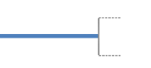



# 

# 

# 

# 

# 

# 

# 

# 

# 

# 

# 

# 

# 

# LOGICALDESIGN

## DATABASE DESIGN (Firebase Firestore)

**Admin Sign Up Database**

**Teacher Sign Up Database**

**Student Sign Up Database**

**Admin/ Teachers Registration Form**

**Student Registration Form**

**Add Courses in Database**

**Add Marks**

# PHYSICAL DESIGN

## OUTPUT REQUIREMENT

* + - **USER INTERFACE DESIGN**

## OUTPUT REPORT DESIGN

* 1. **INPUT REQUIREMENT**

### OUTPUT REQUIREMENTS

* check attendance
* student transport detail
* Help
* Home
* See students and teacher detail
* See homework, time table, notice, result, etc.

#### USER INTERFACE DESIGN

User interface design focus on the user experience and interaction. The goal of user interface design is to make the user’s interaction as simple the efficient as possible.

The following characteristics are considered during the user interface design:

* + Easy to use
  + Easy to learn
  + Easy to navigate
  + Intuitive
  + Consistent
  + Efficient
  + Error-free
  + Functional

As we know college management system is a web base application so in order to design the interface, we have used the following technologies:

* FLUTTER
* DART
* FIREBASE etc.

Some of the design components are as follows:

* Single line text input

This controls permit the users to entry of any character data. Text input controls accept a string value and contribute it to the form data set.

#### OUTPUT REPORT DESIGN

Computer are the most important sources of information to the users. Input is fed into the computers to acquire the necessary outputs. The computer can provide the well enough output in the form of information regarding various items to the user. The major form of output is the hard copy from the printer.

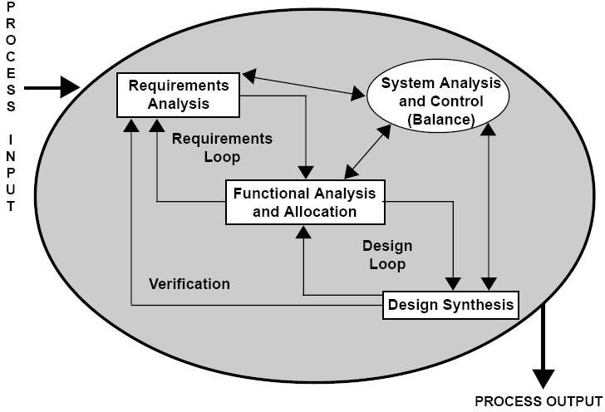

### INPUT REQUIREMENTS

* Login page get the input of user id and password.
* Create the new user id for your profile yourself.
* Compose mail.
* Attach the file with mail.
* View responses.
* Change password
* Search
* Chat

### TESTING

Software Testing has a dual function; it is used to identify the defects in program and it is used to help judge whether or not program is usable in practice. Thus, software testing is used for validation and verification, which ensure that software conforms to its specification and meets need of the software customer.

Developer resorted Alpha testing, which usually comes in after the basic design of the program has been completed. The project scientist will look over the program and give suggestions and ideas to improve or correct the design. They also report and give ideas to get rid of around any major problems. There is bound to be a number of bugs after a program have been created.

##### TEST CASES

A test case is a set of conditions or variables and inputs that are developed for a particular goal or objective to be achieved on a certain application to judge its capabilities or features.

It might take more than one test case to determine the true functionality of the application being tested. Every requirement or objective to be achieved needs at least one test case. Some software development methodologies like Rational Unified Process (RUP) recommend creating at least two test cases for each requirement or objective; one for performing testing through positive perspective and the other through negative perspective.

##### Test Case Structure

A formal written test case comprises of three parts -

##### Information

Information consists of general information about the test case. Information incorporates Identifier, test case creator, test case version, name of the test case, purpose or brief description and test case dependencies.

##### Activity

Activity consists of the actual test case activities. Activity contains information about the test case environment, activities to be done at test case initialization, activities to be done after test case is performed, and step by step actions to be done while testing and the input data that is to be supplied for testing.

##### Results

Results are outcomes of a performed test case. Results data consists of information about expected results and the actual results.

##### Designing Test Cases

Test cases should be designed and written by someone who understands the function or technology being tested. A test case should include the following information -

* Purpose of the test
* Software requirements and Hardware requirements (if any)
* Specific setup or configuration requirements
* Description on how to perform the test(s)
* Expected results or success criteria for the test

### MAINTENANCE

Software will definitely go through change once when it is delivered to the customer. There are large numbers of reason for the change. Change would happen due to some unpredicted input values into the system. In addition to this, the changes in the system directly have an effect on the software operations. The software should be implemented to accommodate changes that could be happen during the post development period

# SCREENSHOTS





Departments

List

Home

Page

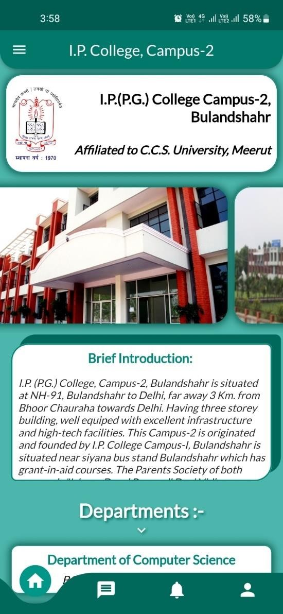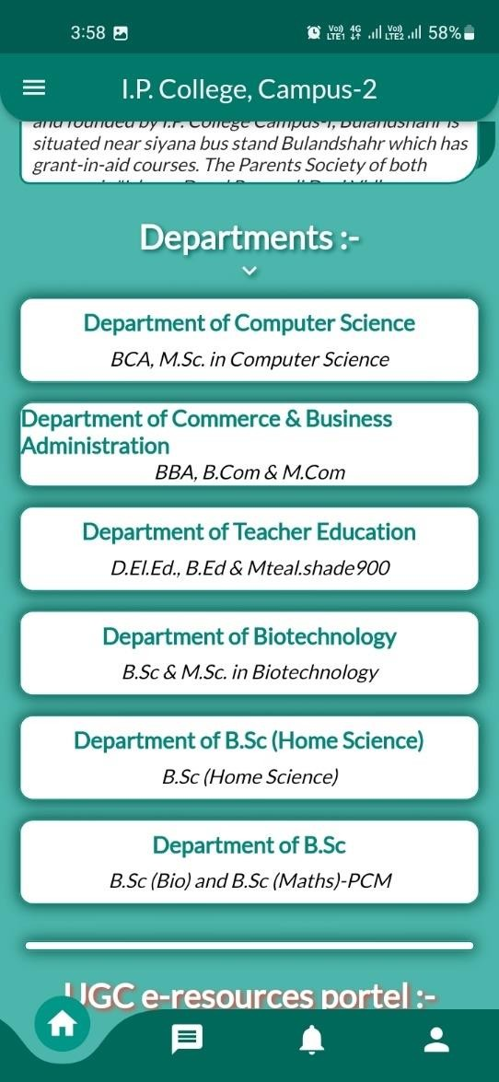

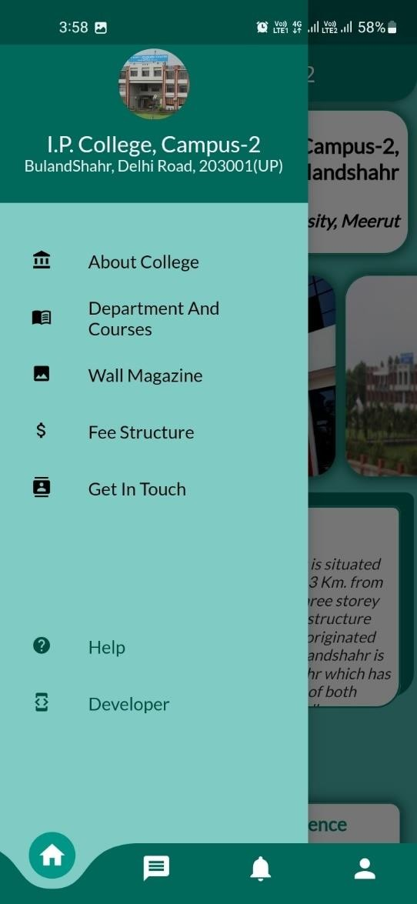 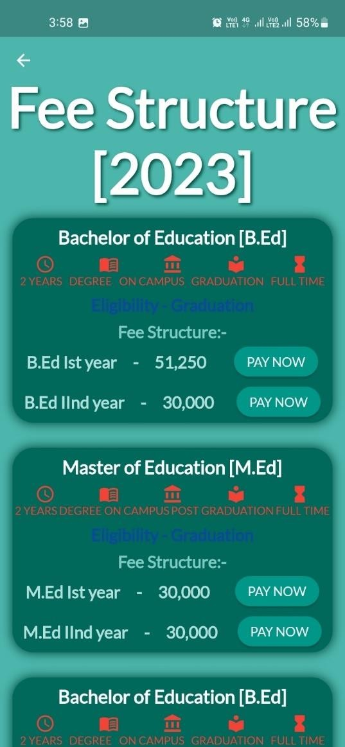

Fee

Structure

Navigation Drawer



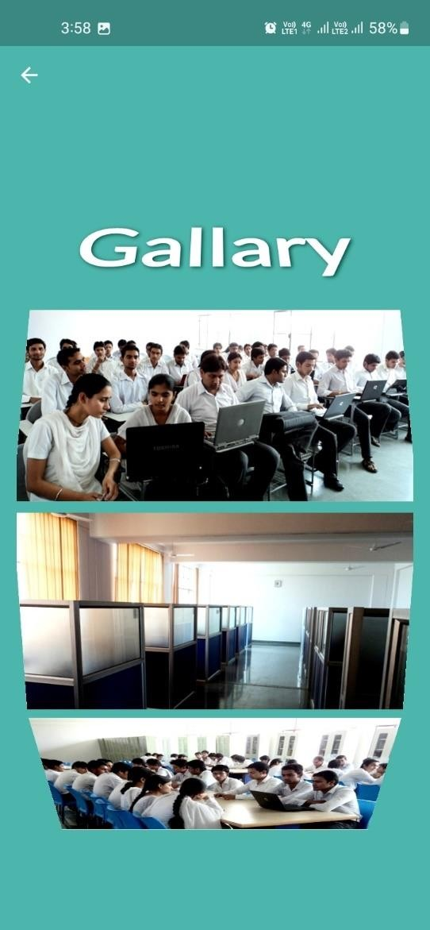 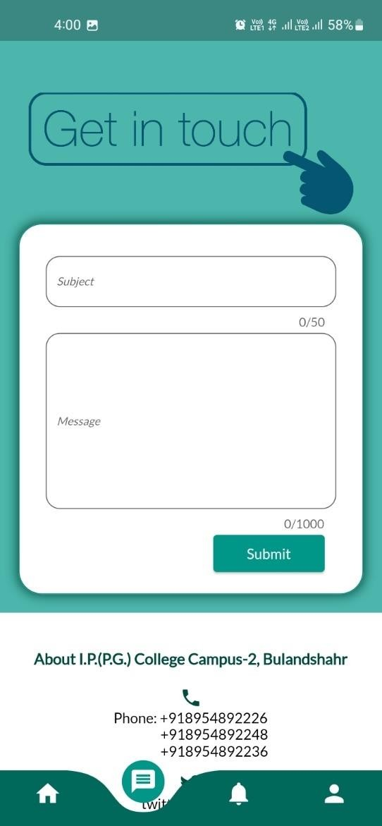

Get In

Touch

Photo

Gallery



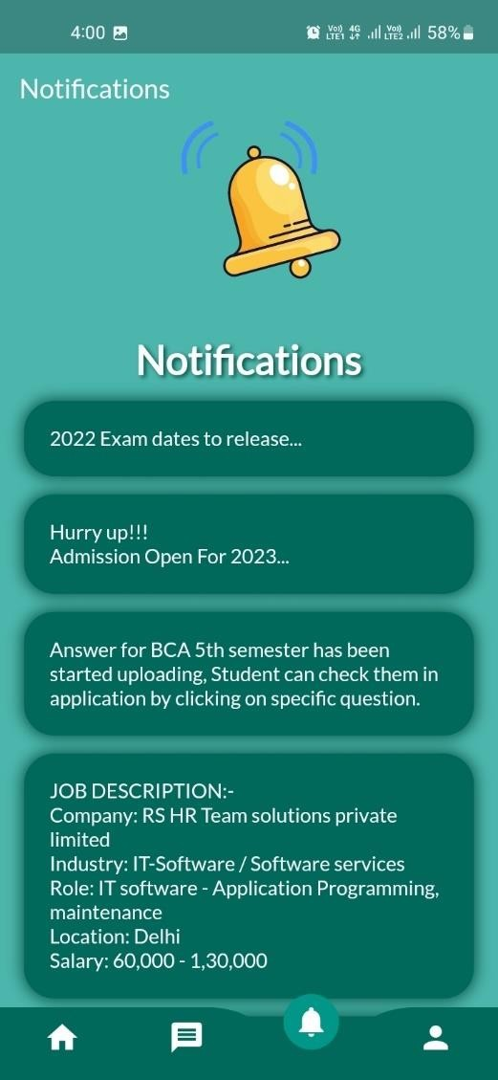 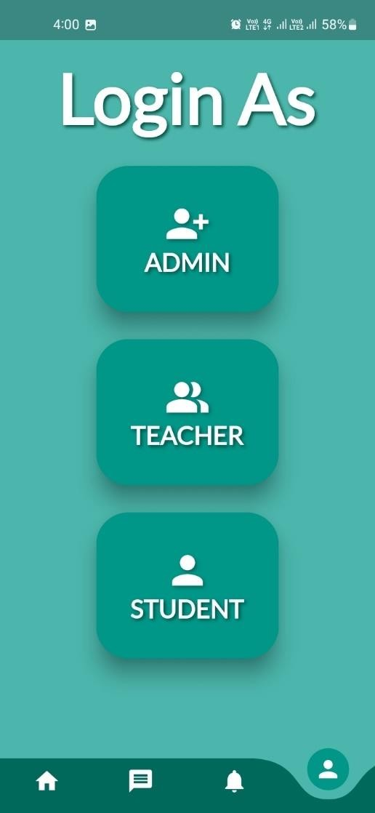

Who

Are You

Notification

Page

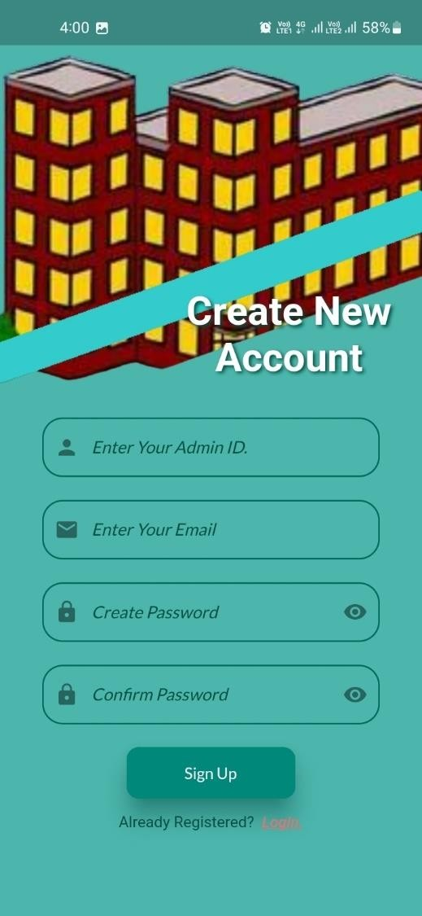 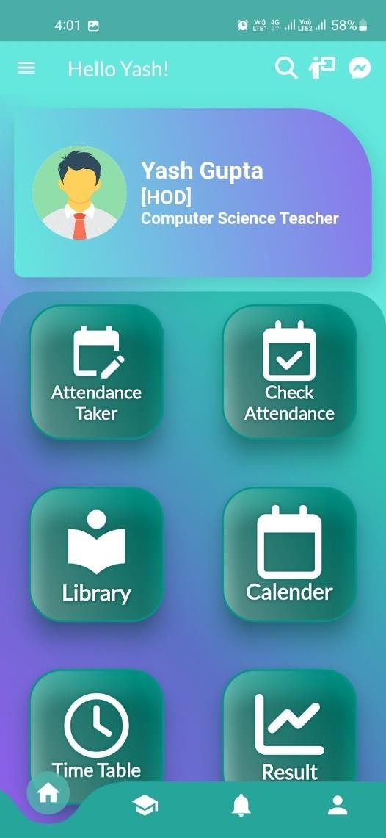

Admin

Home Page

Sign Up

Page

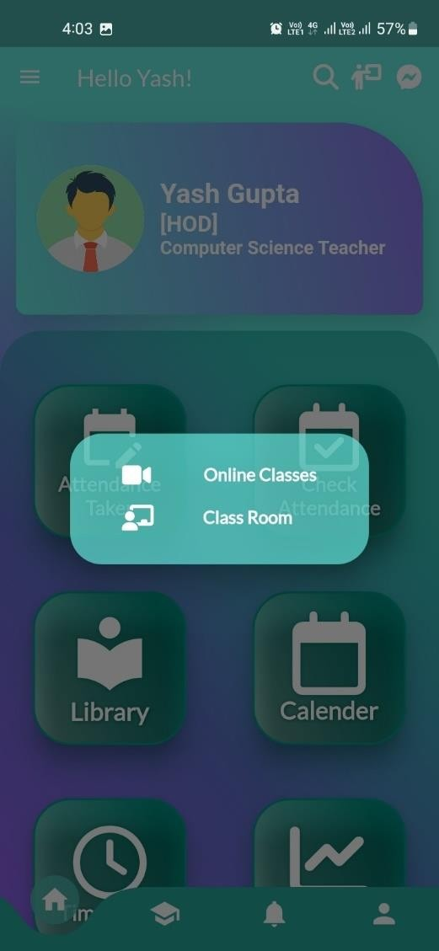 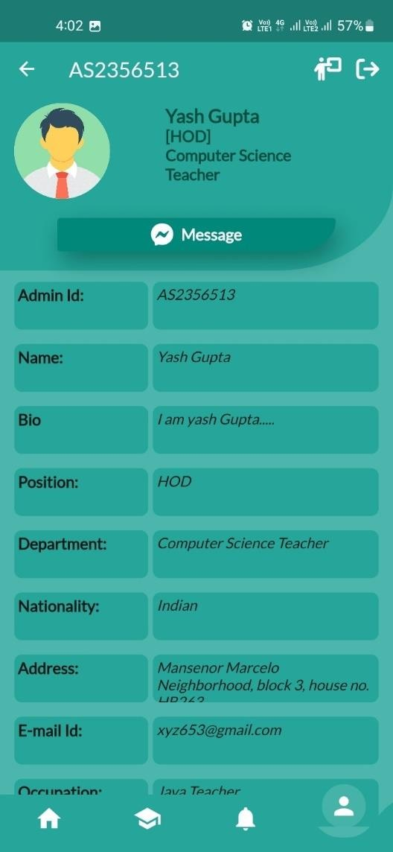

Admin

Profile

Online

Class &

Room

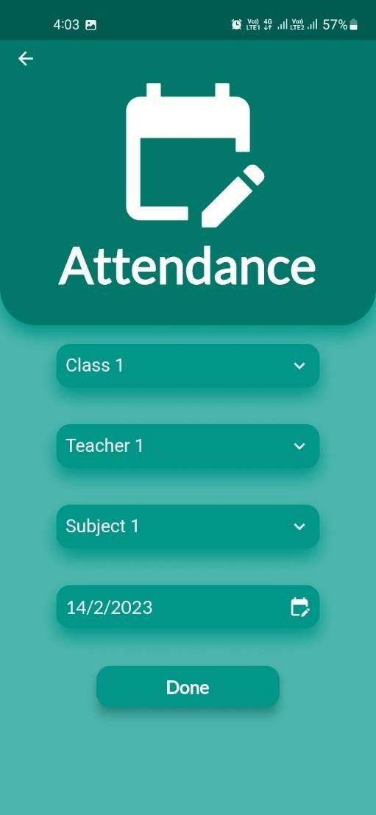 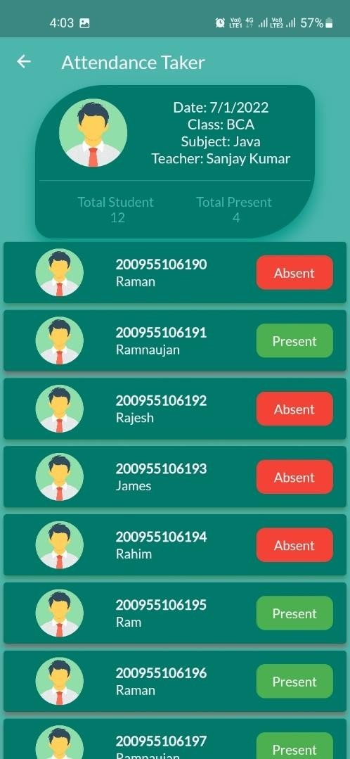

Attendance

Form

Attendance

Taker

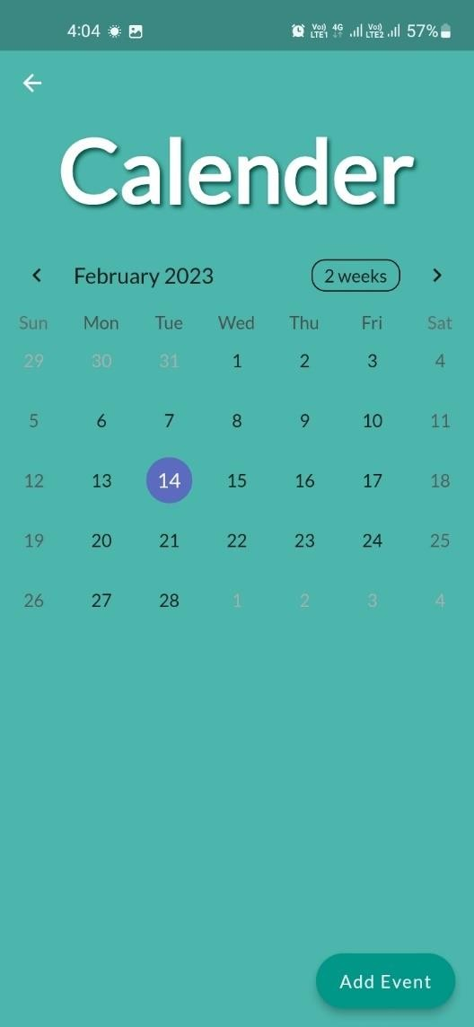 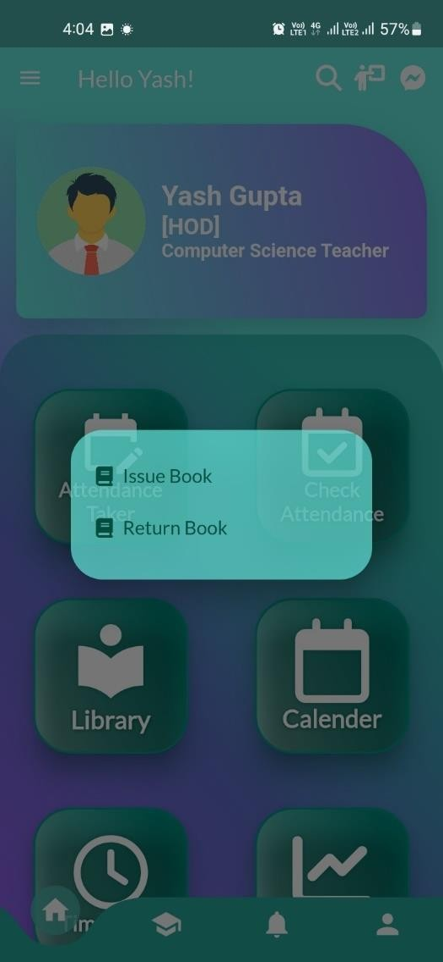

Library

Option

Event

Calendar

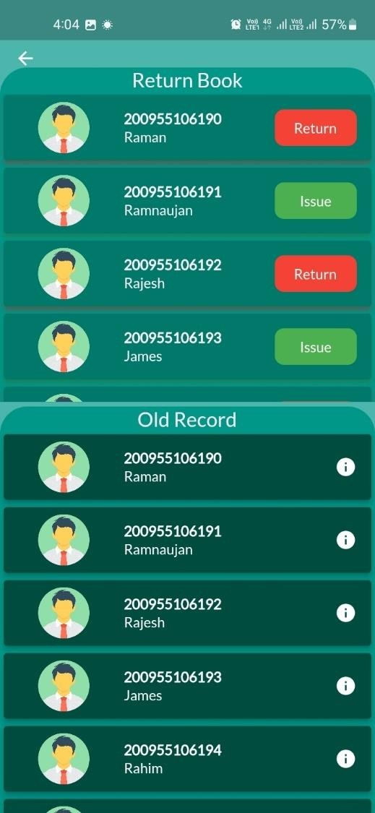 

Time

Table

Library

Record

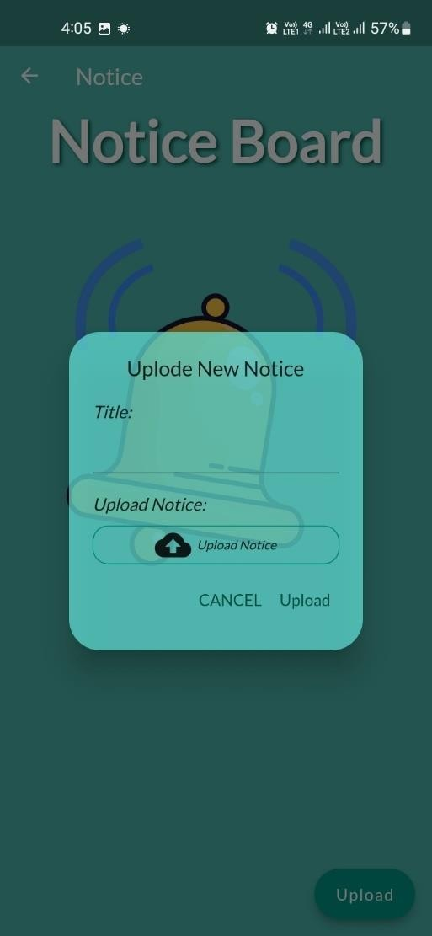 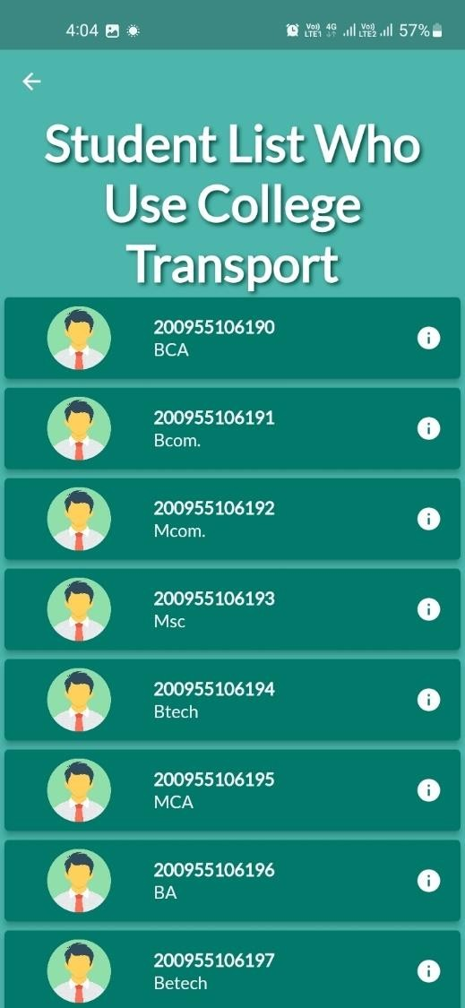

Transport

Detail

Notice

Board

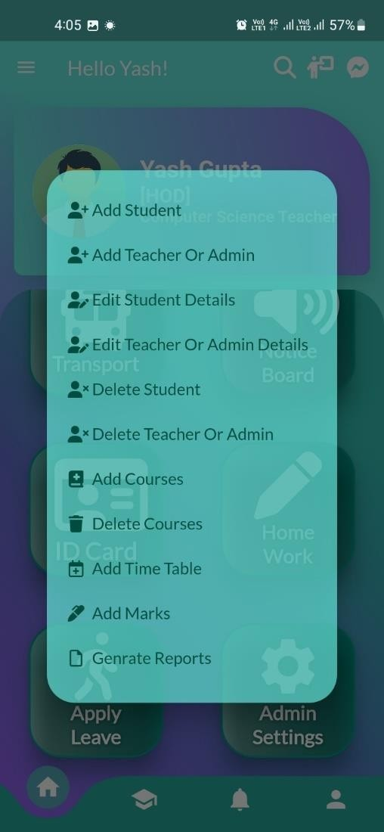 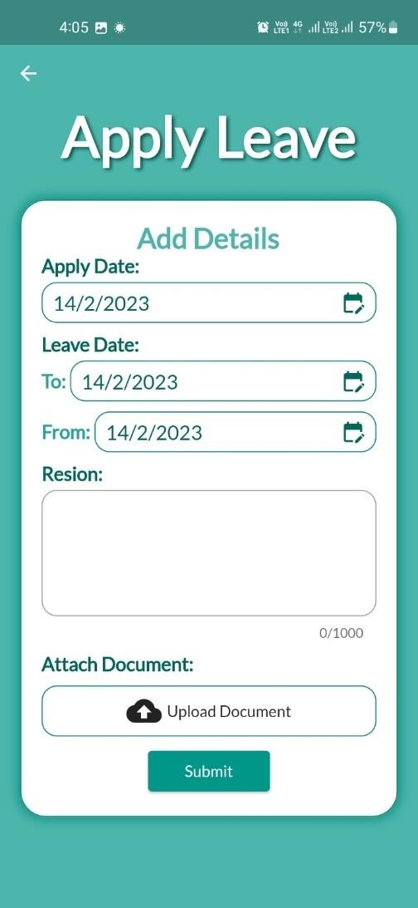

Admin

Settings

Apply

Leave

### LIMITATIONS / FUTURE SCOPE

The part of the system can be implemented using the current technology although some modifications had to be done at various places. At various places some alterations with the prototypes and functionalities would be done in order to work out the cost constraints and to cope with the scheduling constraints.

* In this system we have don’t have facility for attendance management of student and staff.
* In this application search is limited to String or by number. Cannot do search by photo and figure prints.

##### FURTHER ENHANCEMENT

As the current system is expected to add more functionality and dependency according to requirement changes and technology, proper coding standards and working platform have been kept in mind to produce a quality product.

The future extension plans of the project is summarized as follows:

* This application is in more than 1 languages.
* This will provide the information of attendance of each student and staff.
* This will provide the information of each student and staff secured marks.
* This will provide new update according to the user feedback.
* This will provide the SMS facility.
* This will provide information of teacher as well.
* This will also provide attendance of teacher.

# REFRENCES/ BIBLIOGRAPHY

1. **WEB SITE**
2. **YOUTUBE**

### WEB-SITE

* + [Flutter - Build apps for any screen](https://flutter.dev/)
  + [Flutter Tutorial - GeeksforGeeks](https://www.geeksforgeeks.org/flutter-tutorial/)
  + [Stack Overflow - Where Developers Learn, Share, & Build Careers](https://stackoverflow.com/)

### YOUTUBE

* + [(159) Flutter - YouTube](https://www.youtube.com/%40flutterdev)
  + [(159) What is Flutter? & How it is Better than it's Counterparts? - Cross Platform | Full Tutorial -](https://www.youtube.com/watch?v=jqxz7QvdWk8&list=PLjVLYmrlmjGfGLShoW0vVX_tcyT8u1Y3E) [YouTube](https://www.youtube.com/watch?v=jqxz7QvdWk8&list=PLjVLYmrlmjGfGLShoW0vVX_tcyT8u1Y3E)
  + [(159) Master Flutter in Just 8 Hours | Full Course Hindi @HindiCodepur - YouTube](https://www.youtube.com/watch?v=j-LOab_PzzU)
  + [(159) HeyFlutter․com - YouTube](https://www.youtube.com/%40HeyFlutter)

